 Hi Team,

Please find my Git details,

When I try to configure:

<https://github.com/christujesus/Capstone_Project.git>,

My doubt is when I try to install Maven in I given the above git details and configured I got error, All screenshot given below in the document.

1. Please let me know Java file name , and which file name I have to give when I start Jenkin maven ?
2. Please let me know can I run this in freestyle project only ? or pipe line?
3. What I will do (modify) to run this code.

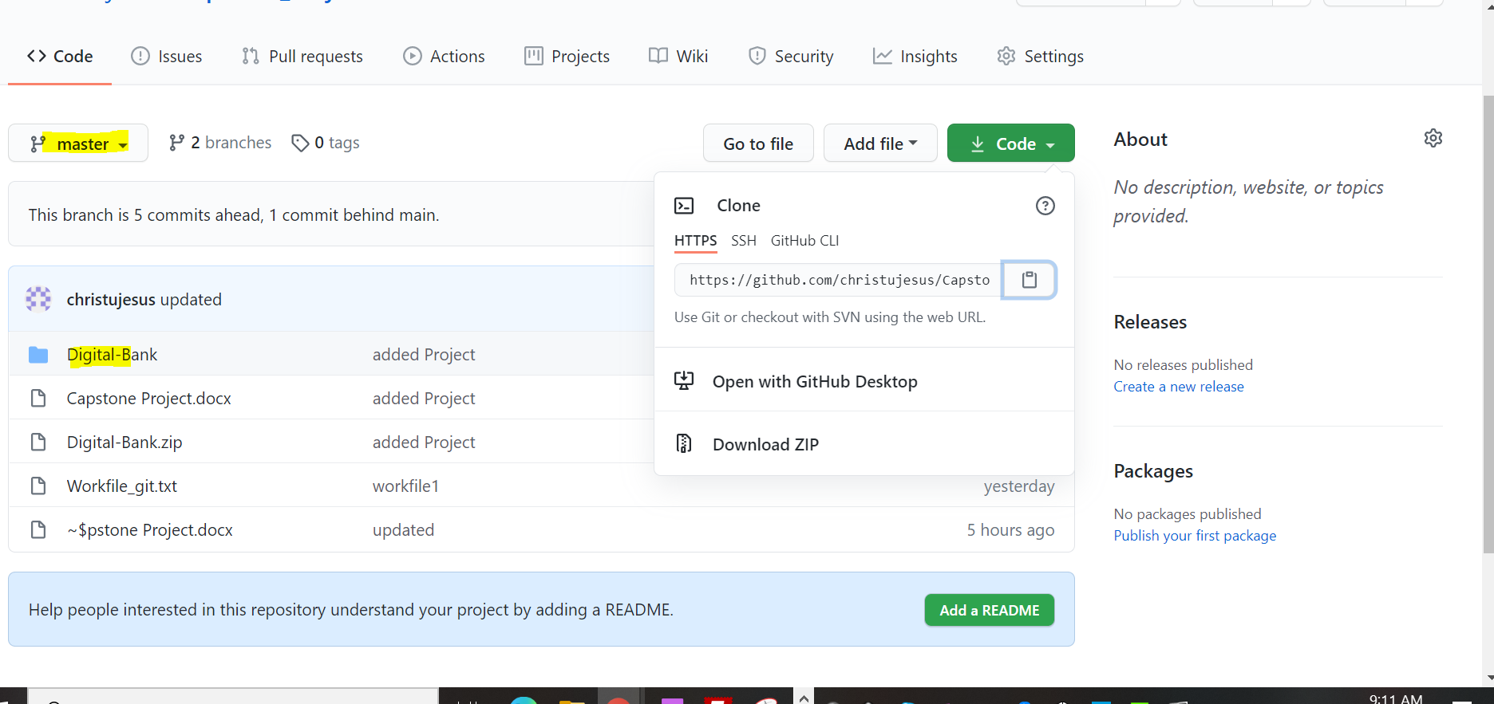

Machine generated alternative text:
ubuntu@ip-172-31-40-61: N/DevOpsMasterJenkins/installation 
lowTcpForwarding yes 
*Gatewayports no 
X11Forwarding yes 
#X11Disp1ayoffset 10 
#X11UseLoca1 host yes 
#PermitTTY yes 
pri ntM0td no 
#printLastLog yes 
Ve yes 
'#UseLogin no 
#permituserEnvi ronment no 
*compression delayed 
clientA1ive1nte rval 
30 
cl i entA1 i vecountMax 
90 
#UseDNS no 
#pidFi1e /var/run/sshd. pid 
#Maxstartups 10: 30: 100 
#permi tTunne1 no 
#ChrootDi rectory none 
#versionAddendum none 
# no default banner path 
#Banner none 

Machine generated alternative text:
A Not secure 1 
Imported From IE 
Imported 
wver 
Getting Started 
DevApp 
Bookmarks bar 
w 
Home - Workday DXC-CATW 
Unlock Jenkins 
To ensure Jenkins is securely set up by the administrator, a password has been written to 
the log (not sure where to find it?) and this file on the server: 
/var/1ib/jenkins/secrets/initia1AdminPassword 
Please copy the password from either location and paste it below 
Administrator password 
Continue 

/var/lib/jenkins/secrets/initialAdminPasswor

sudo cat /var/lib/jenkins/secrets/initialAdminPassword

7569a1bf7d62487881bc7a758d113e13 // password

Machine generated alternative text:
C A Not secure 
server 
| 52.66.206.213:8080 
Imported From IE 
Imported 
DevApp 
Bookmarks bar 
W 
Home - Workday 
DXC-CATW 
Getting Started 
Getting Started 
o ers 
Timestamper 
Pipeline 
Git 
LDAP 
Jenkins 2.249.2 
Formatter 
Workspace Cleanup 
GitHub Branch Source 
SSH Build Agents 
Email Extension 
Ant 
Pipeline: GitHub Groovy 
Libraries 
Matrix Authorization 
Strategy 
Mailer 
Folders 
OWASP Markup Formatter 
Gradle 
Pipeline: Stage View 
PAM Authentication 
required dependency 

Machine generated alternative text:
A Not secure 
| 52.66.206.213:8080 
Imported From IE 
Imported 
DevApp 
Bookmarks bar 
W 
Home - Workday 
DXC-CATW 
Getting Started 
Create First Admin 
Username: 
Password: 
Confirm password: 
Full name: 
E-mail address: 
Jenkins 2.249.2 
das 
christudas 
christudasj@gmail.coml 
User 
Skip and continue as admin 
Save and Continue 

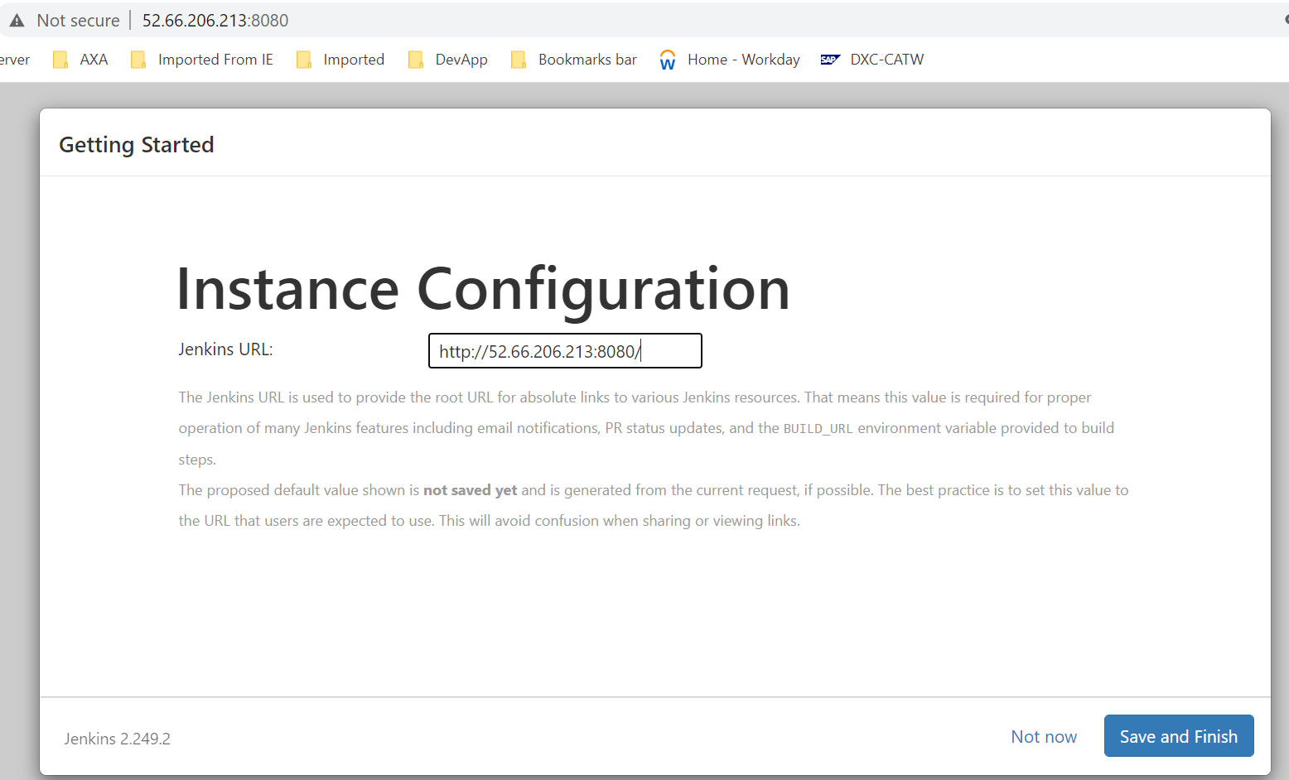

<http://52.66.206.213:8080/>

Machine generated alternative text:
Apps 
C A Not secure 
server 
| 52.66.206.213:8080 
Imported From IE 
Imported 
DevApp 
Bookmarks bar 
W 
Home 
- Workday DXC-CATW 
search 
Jenkins 
Jenkins 
New Item 
People 
Build History 
Manage Jenkins 
My Views 
Lockable Resources 
New View 
Build Queue 
No builds in the queue. 
O 
christudas 
Welcome to Jenkins! 
Create an agent or configure a cloud to set up distributed builds. Learn more 
Create a job to start building your software project. 

Jenkin test project

Machine generated alternative text:
C 
Apps 
Jenkins 
A Not secure 
server 
All 
1 52.66.206.213:8080/view/all/newJob 
Imported From IE 
Imported 
DevApp 
Bookmarks bar 
W 
Home - Workday 
DXC-CATW 
Enter an item name 
jenkintest 
» Required field 
Freestyle project 
This is the central feature of Jenkins. Jenkins will build your project, combining any SCM with any build system, and this can be even 
used for something other than software build. 
Pipeline 
Orchestrates long-running activities that can span multiple build agents. Suitable for building pipelines (formerly known as workflows) 
and/or organizing complex activities that do not easily fit in free-style job type. 
Multi-configuration project 
Suitable for projects that need a large number of different configurations, such as testing on multiple environments, platform-specific 
builds, etc. 
OK 
iner that stores nested items in it. Useful for grouping things together. Unlike view, which is just a filter, a folder creates a 
:ont_ 

Machine generated alternative text:
Apps 
C A Not secure 
server 
Jenkins 
jenkintest 
Changes 
Workspace 
Build Now 
Configure 
Delete Project 
Rename 
Build History 
find 
Nov 2, 2020, 12:57 AM 
1 52.66.206.213:8080/job/jenkintest/ 
[A Imported From IE 
Imported 
DevApp 
Workspace 
trend 
Recent Changes 
Permalinks 
x 

Machine generated alternative text:
Jenkins 
Jenkins 
jenkintest 
Back to Project 
Status 
Changes 
Console Output 
View as plain text 
Edit Build Information 
Delete build '#1' 
search 
Console Output 
Started by user christudas 
Running as SYSTEM 
Building in workspace /var/lib/jenkins/workspace/jenkintest 
[jenkintest] $ /bin/sh -xe /tmp/jenkins140061e9813836077922.sh 
+ echo Hello JenkinWor1d 
Hello JenkinWor1d 
+ echo Welcome to Jenkins 
Welcome to Jenkins 
Finished: SUCCESS 

Machine generated alternative text:
C 
A Not secure 1 65.0.133.248:8080/configureTools/ 
Apps 
Jenkins 
server 
Imported From IE 
Imported 
DevApp 
Bookmarks bar 
W 
Home - Workday 
DXC-CATW 
Global Tool Configuration 
Maven 
Maven installations 
Apply 
Add Maven 
Maven 
Name 
V13 
Install automatically 
Install from Apache 
Version 3.6.3 v 
Add Installer 
Add Maven 
List of Maven installations on this system 
Delete Installer 
Delete Maven 

<https://github.com/christujesus/Capstone_Project.git>

How to compile ?

* Execute "mvn clean compile"
* Mvncleancompile
* 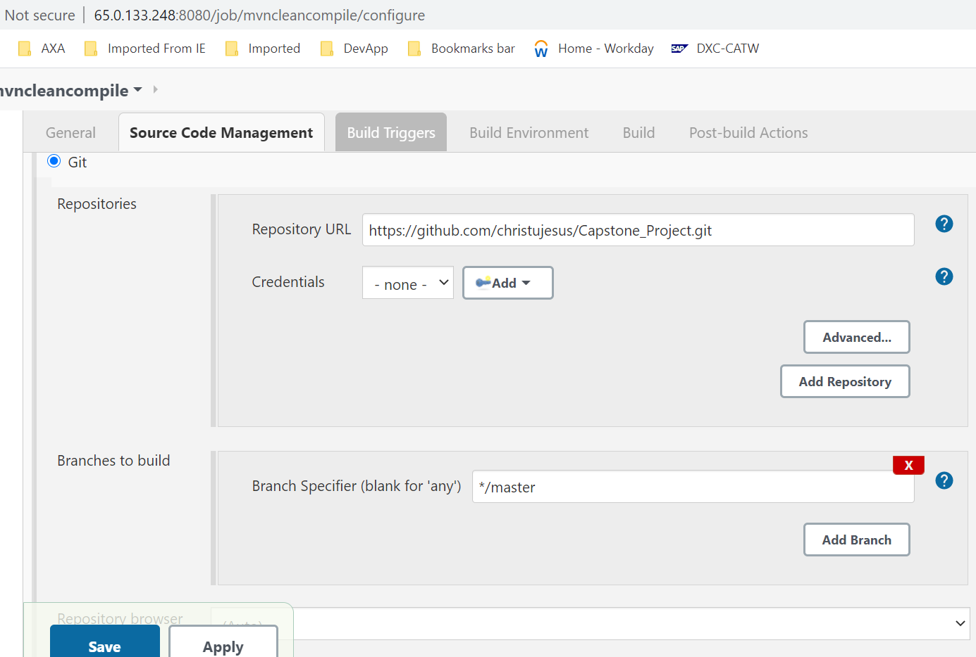



Machine generated alternative text:
C 
A Not secure | 65.0.133.248:8080/job/mvncleancompile/configure 
Apps 
Jenkins 
server 
Imported From IE 
Imported 
Bookmarks bar 
DevApp 
W 
Home - Workday 
mvncleancompj!e 
General 
Source Code Management 
nspect og or pu IS e ra e 
D With Ant 
Build 
- Invoke top-level Maven targets 
Maven Version 
DXC-CATW 
Post-build Actions 
Build Triggers 
UI scans 
Build Environment 
Build 
Goals 
Add build step 
Save 
V13 
compilel 
Apply 
Advanced... 

